**Exercise No:8**

**Register No:1518102066**

**Date:21.11.20**

**Aim:** To write a python program to get list,sorted in increasing order by the last element in each tuple from a given list of non empty tuples.

**Program:**

def last(n):return n[-1 ]

def sort_list_last(tuples):

return sorted(tuples, key=last)

print(sort_list_last([(2, 5), (1, 2), (4, 4), (2, 3), (1,2))

**Link:**

[**http://103.53.53.18/mod/vpl/forms/edit.php?id=317&userid=1681**](http://103.53.53.18/mod/vpl/forms/edit.php?id=317&userid=1681)

**Output:**

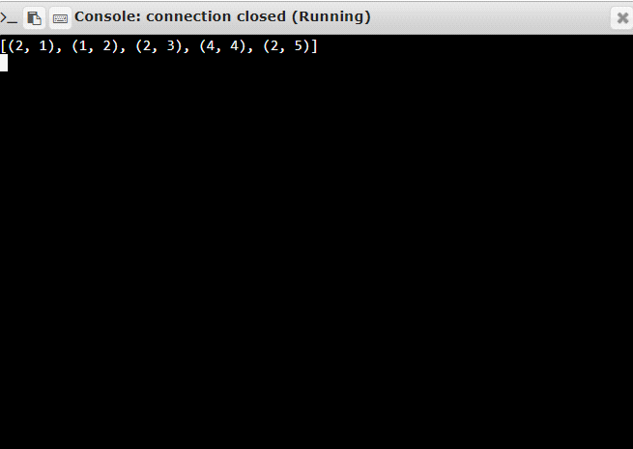

**Result:**Thus , the program is executed successfully and the output is verified.